**Audio Hyper-sensitivity Program for Children:**

**Context/Story:**

*Does your child get agitated by the noise of pressure pumps or construction noises from your neighbourhood?*

*Does your child struggle to focus or seem distressed in places like a crowded mall or a bustling classroom?*

*Does your get anxious by the traffic noises around your home?*

If yes, our audio hyper sensitivity program rightly found your child!

Children with audio hypersensitivity experience heightened sensory input across a wider frequency range. When exposed to sounds beyond 20-20,000 Hz, sensory overload occurs, leading to challenges such as difficulty concentrating, avoiding social interactions, and impaired **primary socialization**. **This overload also disperses attention when multiple audio inputs are present, making it hard for the child to focus. It often co-occurs with mental health conditions like anxiety or sensory processing disorders, due to dysregulation of the brain's auditory system, and can contribute to autism and related conditions.** AHS also has a positive correlation with children’s sleep deficit.

We know that children with AHS experience high levels of cortisol and low levels of melatonin, the opposite of what is typical (and recommended) to support sleep cycles. Research indicates that behavioural and physiological measures are able to predict good sleepers versus poor sleepers with 85.7% accuracy, suggesting that atypical auditory behaviours are important to consider in relation to sleep deficits in children**.**

Findings indicate that a significant proportion of Indian children experience auditory hypersensitivity, with prevalence rates ranging from approximately 14.6% to 17.25% in the studied groups. It's important to note that prevalence rates can vary based on factors such as age, region, and assessment methods.

* **Early warning signs of AHS:** 
  + - Hard to focus
    - Feeling anxious
    - Short temper
    - Headache
    - Ringing in ears
    - Feeling exhausted
    - Emotional meltdown

**Disadvantages of Existing Protocols:**

The commonly used therapies for auditory hypersensitivity face significant challenges:

1. **Noise-Cancelling Headphones:** While helpful in preventing sensory overload, they are neither curative nor preventive, leading to over-reliance. This further leads to the sensory avoidant behaviours.
2. **Cognitive Behavioural Therapy (CBT):** Takes years to show results, is often inaccessible, and significantly disrupts the child’s routine, making adherence difficult.

**Advantages of our Approach:**

Our child-centric program offers gentle, effective solutions tailored to developmental needs. With **minimal disruption to daily routines**, it ensures easy adherence and meaningful progress.

**Modalities of our program:**

1. **Audio Sensitivity Testing**
   * A comprehensive audio test to confirm hypersensitivity.
   * Frequency mapping of hearing to pinpoint sensitivity levels.
2. **Medical Support and Therapy**
   * Personalized audio therapy to desensitize hearing.
   * Matching audio programs to help children distinguish between sounds.
3. **Minimal Medicine for Nerve Rejuvenation**
   * Specially formulated medicines to rejuvenate nerves and establish a proper connection between the vestibular system of the ear and the brain. Our forest sourced herbal medicines Haridaswa Sharava and Mahanandikeshvara Atibala address the root cause, soothes the ear nerves and restore balancing by rejuvenating the vestibular system.
4. **Palatable diet** 
   * We provide a customized plan of diet plan that helps soothe the fatigued and overwhelmed nervous system
5. **Semester-Based Program**
   * A 11-month structured semester format for steady progress.

**Benefits:**

* Improved focus and reduced sensory overload.
* Enhanced social interactions and behaviour.
* Development of coping mechanisms for long-term resilience.
* Improved vestibular system and cognitive restructuring

**Audio Hyper Sensitivity for Adults:**

Maybe you experienced auditory sensory overload - the TV on, the dog barking, the baby crying, the timer on the stove beeping ... and the final straw being your spouse yelling from across the room - and you couldn't handle it anymore! Too much competing noise in your environment and your brain cannot process any more noise - this can cause a fight or flight response. Researchers suggest a whopping 23% prevalence of audio hyper sensitivity and tinnitus among adults. Adults tend to be affected differently by AHS than children:

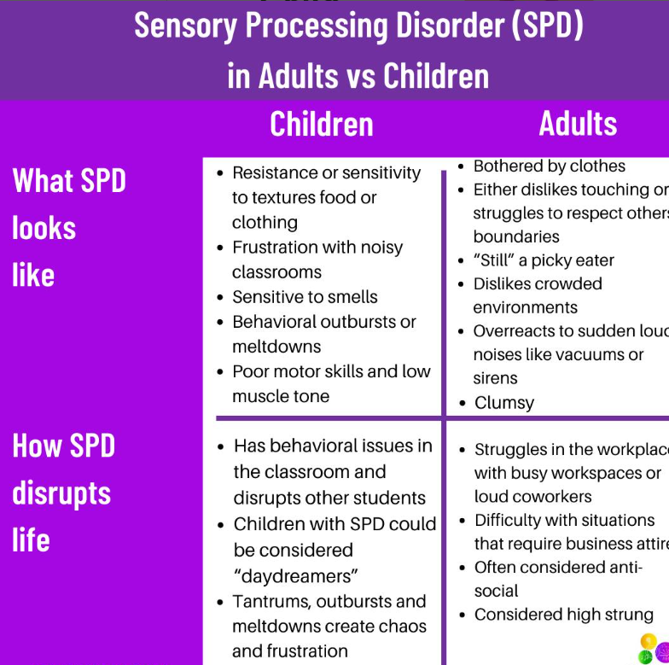

People with Audio Hyper sensitivitytend to have a heightened sensory experience with access to wider range of frequency. The sensory overload becomes overwhelming, when an individual has the audio access beyond 20-20,000 Hz range of frequency. This makes them face unique challenges in their daily lives, including difficulty concentrating in work and avoiding social interactions. This sensory overload often co-occurs with mental health conditions like **anxiety** or **sensory processing disorders** due to **brain auditory system dysregulation.**